Bhartiyam International School
Periodic Assessment I (2022-23)
Subject: EVS (SET -1)
Class -III
Date: 11/7/2022 Max. Mark: 20
Name. _________ Roll no. ______ Duration: 1 hr
General Instructions:
1. The question paper contains four sections.
2. All questions are compulsory.
3. Marks for each question are marked along with.
Section - A
I. Tick the correct answer : (0.5X8=4) i.Which of the following is not an external body organ?
a. eyes b. tongue
c. nose d. lungs
ii. What is the shape of stomach?
a.s-shaped b. j-shaped c. balloon-shaped d. none of these
iii. The heart pumps __________.
a. air b. blood c. plasma d. none of these
iv.I look like my cousin .It is because-
a. we were born in the same city b. we belong to the same family c. we have the same parents d. none of these
v. The ____________help in the exchange of gases.
a. stomach b. heart c. lungs d. windpipe
vi. Which of the following is not a correct family value?
a.teasing your cousins b. greeting someone when they come home c. caring for the elders d. helping your mother in the kitchen
vii. Which of the following organs controls the whole body and helps us to think?
a. heart b. liver c. lungs d. brain
viii. Your father’s mother is your __________.
a.grandmother b. mother c. maternal grandmother d. none of these

II. Define: (1X4=4)
i. Internal organs-_________________________________________________________

_____________________________________________________________________
ii .Enthusiasm-___________________________________________________________

_____________________________________________________________________

iii. Exhalation-___________________________________________________________

_____________________________________________________________________

iv. Tradition-____________________________________________________________

_____________________________________________________________________

Section - B

III. Very Short Answer Type Questions : -
(2X1=2)
i. In what ways are you similar to your family members?

_____________________________________________________________________

_____________________________________________________________________

_____________________________________________________________________

Section - C

IV. Short Answer Type Questions : - (3X2=6)

i.Describe three different ways of taking care of your body. Or
Write three ways to keep your respiratory system healthy.

_____________________________________________________________________

_____________________________________________________________________

_____________________________________________________________________

_____________________________________________________________________

ii.How do you help your elders at home?

_____________________________________________________________________

_____________________________________________________________________

_____________________________________________________________________

_____________________________________________________________________

Section - D

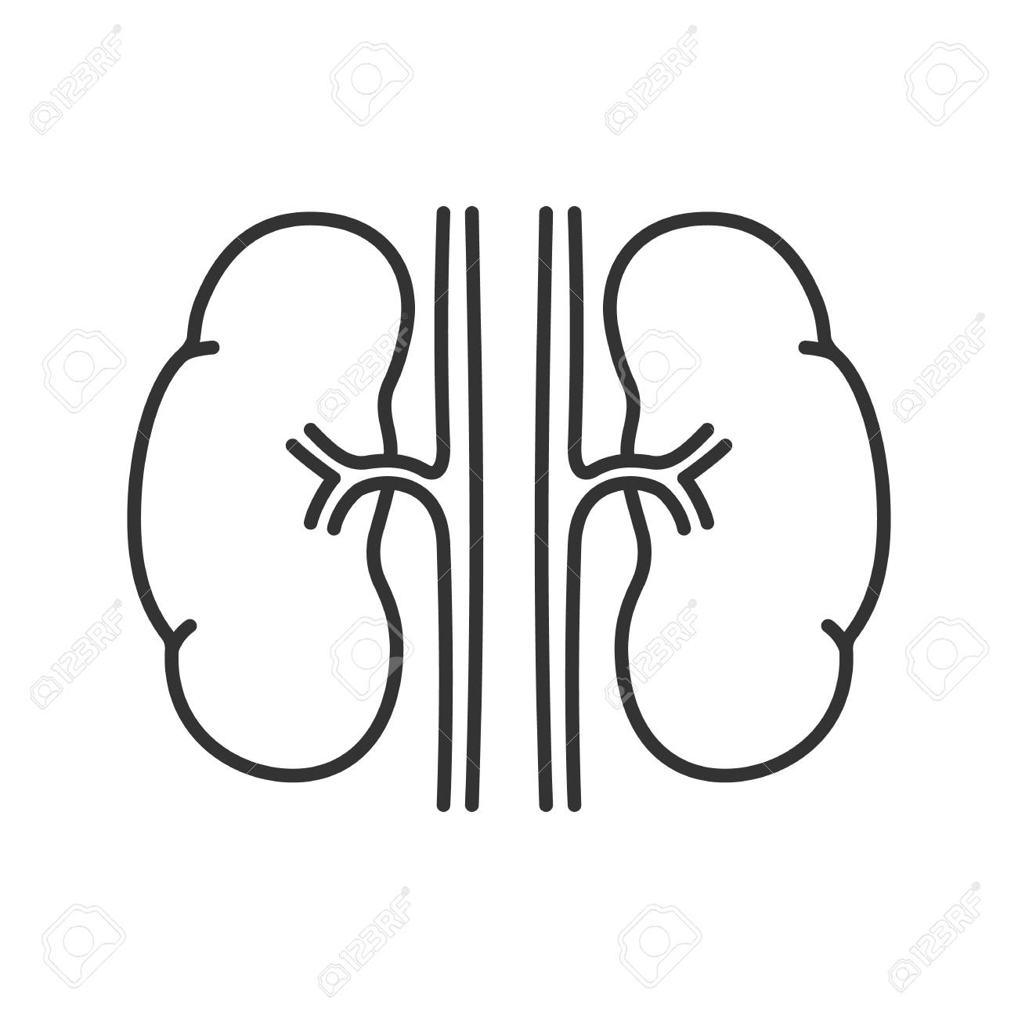
IV. Long answer question: - (4X1=4)
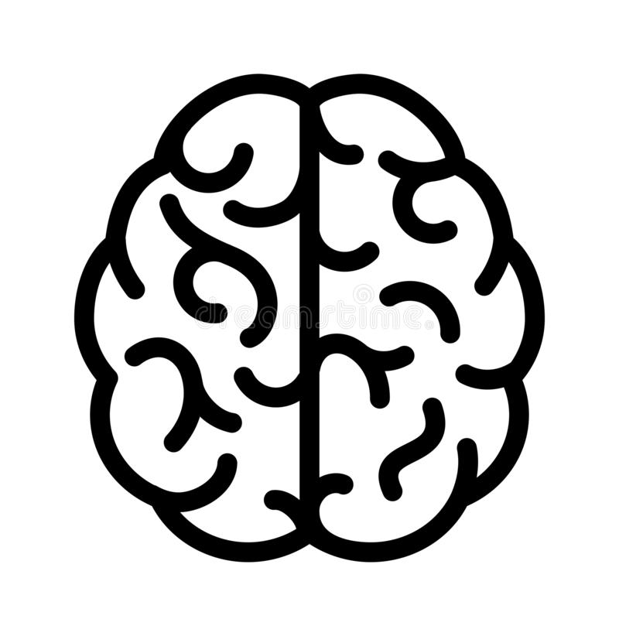
i.Identify the picture and write its function :-

a) b)

a)Name-_________ b)Name-_________
Shape -_________ Shape-_________
Function-________________ Function-________________
_______________________ _______________________
_______________________ _______________________
Or
Give any two differences between the food habits of the following:
a)East India and West India
b)North India and South India
_____________________________________________________________________

_____________________________________________________________________

_____________________________________________________________________

_____________________________________________________________________

_____________________________________________________________________

________________________________________________________________________________________________________________________________________________________________________________________________________________________________________________________________________________________________________________________________________________________________________________________________________________________________________________________________________________________________________________________________________________________________________

